



2025 CVS Health / AACP
Community Pharmacy Award
Last updated: 3/27/2025

Program Information and Application Instructions
Deadline: June 1, 2025, at 11:59 p.m. Hawaii Time (HT)

Table of Contents
THE PROGRAM 3
Description 3
Goal of the Program 3
Eligibility Requirements 3
Scholarship Notification 4
Scholarships Payments 4
Scholarships Questions 4
APPLICATION INSTRUCTIONS 5
APPLICATION DEADLINE 5
APPLICATION BASICS 5
APPLICATION SECTIONS 5
Step 1: Applicant Information 5
Step 2: Eligibility Information 5
Step 3: Letters of Reference – Two (2) Required 6
How to add a reference: 7
Step 4: GPA Verification Upload 8
Step 5: Resume/CV and Activities 8
Step 6: Activities and Leadership 8
Step 7: Applicant Essay 9
Step 8: Applicant Certification 9
EDITING YOUR APPLICATION 9
APPLICATION REVIEW 11
Review Overview 11
Review Criteria 11

THE PROGRAM

Description
The CVS Health / AACP Community Pharmacy Award for Student Pharmacists will be awarded to 21 outstanding student pharmacists who face financial barriers in their pursuit of education. Students must be enrolled in their first (P1) or second (P2) year of the professional phase of the Pharm.D. degree program during the 2025-2026 academic year at an American Association of Colleges of Pharmacy (AACP) member institution. Selected awardees must demonstrate leadership, academic success, and a commitment to care for patients in underserved communities. Each awardee will receive a single $20,000 scholarship.

Goal of the Program
The CVS Health / AACP Community Pharmacy Award is intended to support students who will care for the needs of patients in underserved communities, the profession, and the public, both within and outside healthcare settings. The purpose of the scholarship is to reduce financial barriers for student pharmacists in pursuit of a Pharm.D. degree who are committed to addressing health disparities and the well-being of individual patients in communities across the United States.

Eligibility Requirements
Qualified applicants must meet the following requirements:
- Eligible student statuses during the 2025-26 Program:
  - Students must be enrolled as a first (P1) or second (P2) year Pharm.D. student for the 2025-26 academic year.
  - NOTE: Students enrolled in a 0-6 Pharm.D. program as a P3 or P4 (out of P6) student during the 2025-2026 (current) academic year are also eligible.
- Students must be able to demonstrate that they face financial barriers in their pursuit of education. To qualify, students must have filed or be claimed as a dependent on the most recent Federal Income Tax Return Form 1040, 1040A, or 1040EZ with an adjusted gross income that falls below the Low-Income Level listed below. The Low-Income Level is based on 200 percent of the U.S. Department of Health and Human Services poverty guidelines and used to determine what constitutes a low-income family. (Table 1)
Table 1: 2024 Low-Income Levels
Persons in Family or Household | Income Level
1 | $30,120
2 | $40,880
3 | $51,640
4 | $62,400
5 | $73,160
6 | $83,920
7 | $94,680
8 | $105,440
*For each additional person, add $10,760

- Student must be a U.S. citizen or permanent resident.
- Students must demonstrate leadership, academic success, and a commitment to advancing the pharmacy profession and patient care.
- GPA for current degree program must be 2.5 or greater on a 4.0 scale. Applicants from schools with other grading systems are still eligible to apply for the scholarship.
- Students must submit a completed application by the deadline.
- A student may only receive the CVS Health / AACP Community Pharmacy Award once.

Scholarship Notification

- Completed applications are due Sunday, June 1, 2025, at 11:59 p.m. Hawaii Time (HT)
- Completed applications will be reviewed by August 2025.
- Scholarship recipients will be notified via email during Fall 2025.
- Funds will be forwarded to the student’s institution during Fall 2025.
- Additional information will be requested from awardees (e.g., media release, photo) during Fall 2025.
- AACP will announce the scholarship recipients on the AACP and Pharmacy Is Right for Me websites and social media in Fall 2025.
- CVS may also release related announcements about the scholarship recipients via the company’s communication channels.

Scholarships Payments
A single scholarship in the amount of $20,000 each will be awarded to twenty-one (21) outstanding students. AACP will pay the scholarship funds for each awardee directly to the pharmacy college or school where the student is currently enrolled. Funds will be dispersed in fall 2025 after the 2025-2026 academic year begins. Each institution will exclusively apply the scholarship funds to the awardee’s tuition and/or fees.

Scholarships Questions
Please contact AACP at scholarships@aacp.org with questions.

APPLICATION INSTRUCTIONS

APPLICATION DEADLINE

Applications are due June 1, 2025 at 11:59 p.m. Hawaii Time (HT)

APPLICATION BASICS

- Access the scholarship application online at: https://my.reviewr.com/site/cvs2025
- Review the eligibility criteria under the “RULES” heading to ensure you are eligible for this scholarship.
- Select "CREATE AN ACCOUNT” to begin a new application.
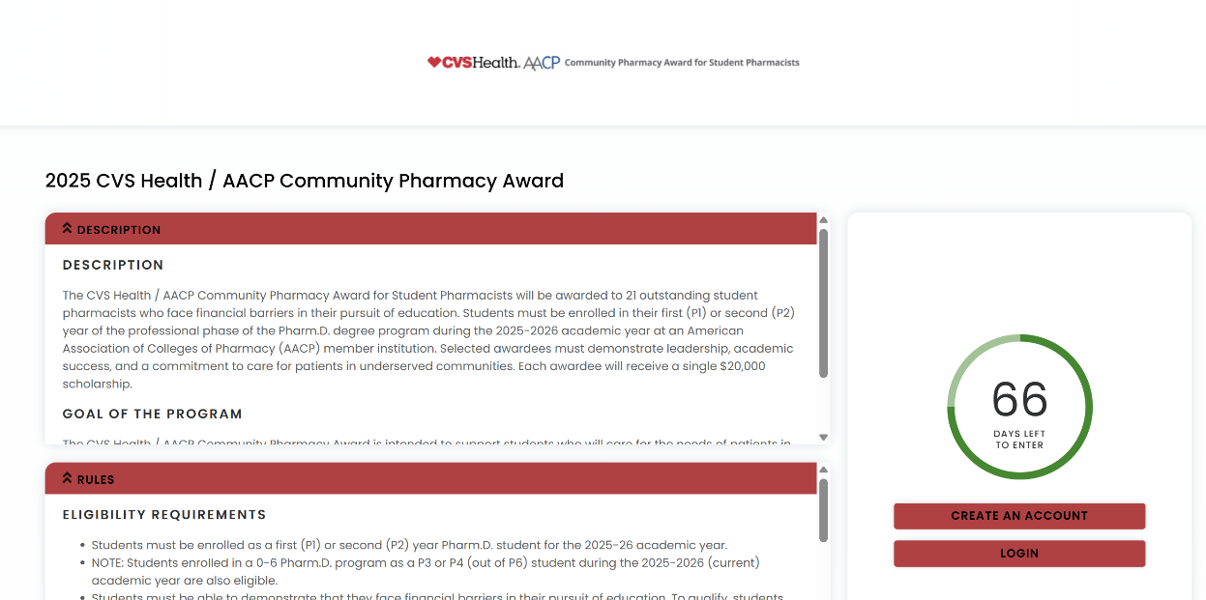

APPLICATION SECTIONS

Step 1: Applicant Information

Name

Current Street Address (this information will not be visible to reviewers or used to determine eligibility)

Email (this information will not be visible to reviewers)

Preferred Phone Number (this information will not be visible to reviewers)

College or School of Pharmacy

Step 2: Eligibility Information

Academic Status
  - Eligible student statuses during the 2025-2026 Academic Year:
    - Enrolled as a first (P1) or second (P2) year Pharm.D. student for the 2025-26 academic year.
  - NOTE: Students enrolled in a 0-6 Pharm.D. program as a P3 or P4 (out of P6) student during the 2025-2026 (current) academic year are also eligible.

GPA Eligibility (this information will not be visible to reviewers)
  - Enter your GPA for your current degree program (undergraduate or Pharm.D). To be eligible for consideration, GPA must be 2.5 or greater on a 4.0 scale. Please enter "N/A" if your school uses a grading scale besides 4.0 (i.e., Pass/Fail).
  - Applicants from schools with other grading systems are still eligible to apply for the scholarship. Please email scholarships@aacp.org, if you have additional questions regarding other grading systems.

Economic Disadvantaged Status (this information will not be visible to reviewers)
  - View the low-income level table on the PharmCAS fee waiver page to determine if you are considered economically disadvantaged.
  - Does your household’s income fall within the table’s guidelines for economically disadvantaged?
    - Yes
    - No
  - I recognize that if I am selected for this scholarship, I will provide evidence of my economic disadvantage status (either a copy of your most recent Federal Income Tax Return Form 1040 or approval of a PharmCAS fee Waiver).
    - Yes
    - No

Service to the Underserved

Which of the following best describes your experience serving in underserved communities?
    - I have actively volunteered or worked in underserved communities for more than 100 hours.
    - I have volunteered or worked in underserved communities for less than 100 hours.
    - I have not volunteered or worked in underserved communities, but I am interested in doing so in the future.
    - None of the above applies to me.

Residency (this information will not be visible to reviewers)
  - Only US citizens and Permanent US Residents are eligible.

Step 3: Letters of Reference – Two (2) Required
Each recommender should describe how you have worked to address health disparities while caring for patients as well as how you have contributed, and will continue to contribute, to the profession of pharmacy.

Contact each recommender in advance, so they know to expect an email from this program.

Recommendation #1: Faculty Member
  - Invite a pharmacy or science faculty member to submit a recommendation on your behalf.
  - Recommendations from non-teaching faculty and academic advisors are also acceptable.

Recommendation #2:
  - Invite a pharmacist, pharmacy scientist, pharmacy researcher, pharmacy school faculty member, or other healthcare professional or educator to submit a letter on your behalf.

How to add a reference:
- Click “ADD NEW”
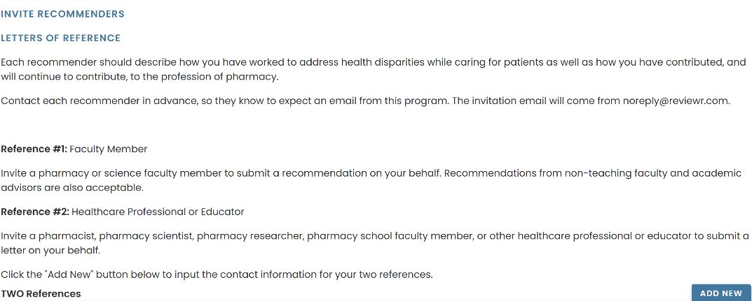
- Enter the reference’s first name, last name, and email address. Do not enter anything for “Supplemental Form Type” as it is already set to default to “Reference for CVS Scholarship…”
- Click “SAVE AND SEND” to trigger the invitation email to be sent to your reference.
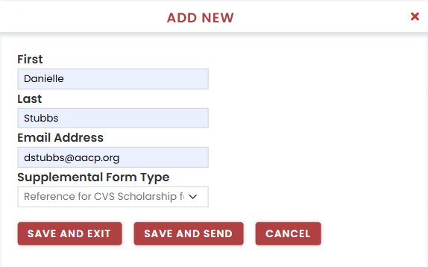
- The reference will now appear, and their status will read “New”.
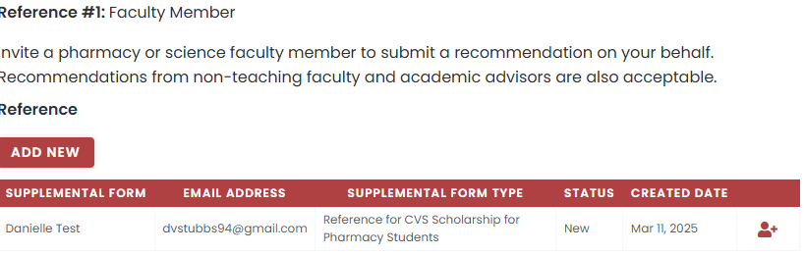
- The email invitation will come from noreply@reviewr.com, and we encourage you to advise your references to add that email to their safe sender list.
- Once your reference has submitted their letter, their status will change to “Ready”.
- We recommend you reach out to your recommenders to ensure that they receive the invitation email. If you need to resend the invitation, click on the “person+” icon on the right.

- If your references do not receive the email, they should contact us at scholarships@aacp.org
- Your application will be considered incomplete until the references are submitted. Applications, including references, must be complete and submitted by the deadline to be considered.
- If you wish to delete a reference you added, you must contact AACP staff at scholarships@aacp.org and we will delete it on your behalf.

Step 4: GPA Verification Upload
Upload an unofficial copy of your most recent transcript for your current degree program as a single PDF. To be eligible for consideration, your overall GPA must be 2.50 or greater on a 4.00 scale. Your GPA and unofficial transcript will only be used to determine eligibility and not otherwise considered in the review process.

Applicants from schools with other grading systems are still eligible to apply for the scholarship. If you attend an institution with a non-standard grading system, upload a PDF copy of your transcript with the grading system description included. The grading system can usually be found on the back of the transcript.

Please email scholarships@aacp.org, if you have additional questions regarding the GPA verification process.

Step 5: Resume/CV and Activities
Your resume is a very important part of your scholarship application. It will be used to help differentiate your application from others and allow you to showcase your academic and extracurricular involvement. Review the requirements below before you upload your resume.
- Save and submit your resume as a PDF.
- If you use any acronyms, also provide the full name.
- Use headers and/or section titles to organize your resume.
- Briefly describe any leadership roles and/or involvement.
- Include length of time spent at each organization and in each leadership role.

Step 6: Activities and Leadership
This section is an opportunity to expand upon your resume and/or include additional activities. It will be used to help differentiate your application from others and allow you to showcase your academic and extracurricular involvement. Be sure to include experiences, achievements, extracurricular activities, leadership roles and/or involvement as well as length of time spent in organizations and/or leadership roles.

Leadership Activities:

Describe your activities and leadership in academic, collegiate, or university sponsored organization, club, research or activity

Describe your activities and leadership in non-academic related environments (for example volunteering, work, civic groups)

Be sure to include experiences, achievements, extracurricular activities, leadership roles and/or involvement as well as length of time spent in organizations and/or leadership roles.

Step 7: Applicant Essay
You are strongly encouraged to compose your essay in a separate word processor, then copy and paste as plain text into the text box. Use line breaks (the return key) to separate paragraphs. Please do NOT insert hyperlinks or other formatting. Limit essay to 6000 characters. Although you may utilize mentors, peers, advisors, and/or artificial intelligence (AI) tools or other online resources for proofreading or editing, your final submission must be a true reflection of your own work and must represent your individual ideas, thoughts, and experiences.

Essay : Describe how your lived experiences have informed/contributed to your desire to address the public health and well-being of individual patients in communities across the United States.

Step 8: Applicant Certification

I consent to sharing my name, email, pharmacy school, graduation year, and resume with CVS Health to receive information about career opportunities and programs.
- I agree to share my information
- I do not agree to share my information

**Please note that you are not required to agree to sharing your information with CVS Health. Not agreeing to share your information will not impact your application.

Applicant Certification

By adding my name to the text box below, I certify that all the information and statements I have provided in this application are current, correct, and complete to the best of my knowledge. I certify that all writing submitted by me as a part of this application is my own. This includes, but is not limited to, any personal essays or written responses. Although I may utilize mentors, peers, advisors, and/or artificial intelligence (AI) tools or other online resources for proofreading or editing, my final submission is a true reflection of my own work and represents my individual ideas, thoughts, and experiences.

I understand my certification of this statement serves the same purpose as a legal signature.
- Check “I certify”.
- Add your full name to the text box to indicate your agreement.
- Select today’s date.
- If you are ready to submit your completed application, click “Submit”.

Your certification of this statement serves the same purpose as a legal signature.

EDITING YOUR APPLICATION

Editing AFTER Submitting

If you need to edit your application after you have submitted it, you can do so by logging back in at https://my.reviewr.com/site//cvs2025 and clicking on the blue “EDIT” button on the top right corner. Please note that you can only edit your application until the deadline. After the deadline has passed, no more edits can be made. No exceptions.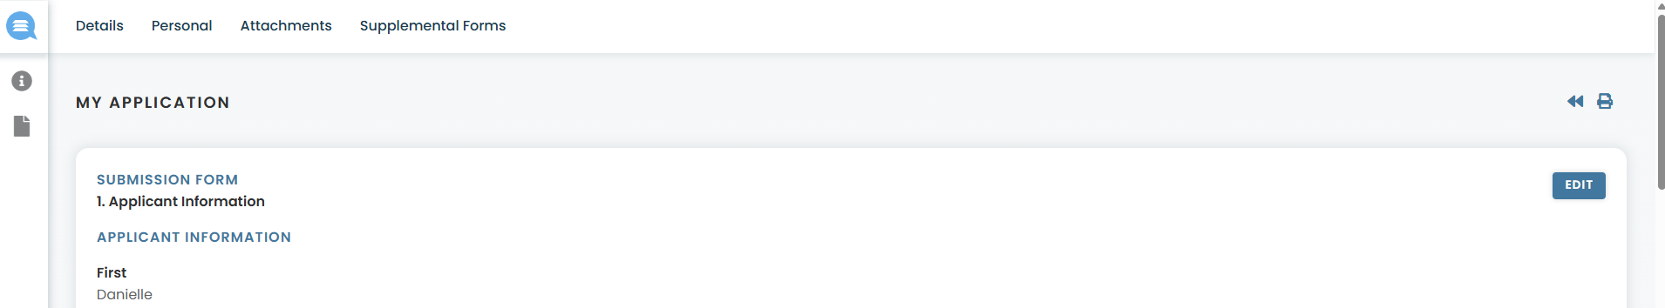
Checking Status of References

You can submit your application even if your references have not submitted their recommendation letters. To check the status of your references after submitting your application, log in and click on “Supplemental Forms” at the top. You can also resend invitation emails from here by clicking on the “person +” icon next to the reference’s name.

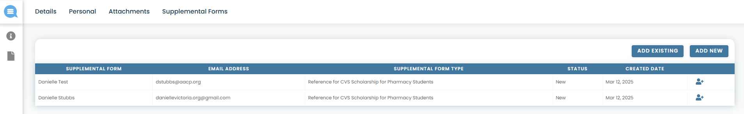
Status Meanings

- “New”: Reference has not yet logged in to begin submitting their letter.
- "Incomplete”: Reference has logged in to the platform but not yet submitted their letter.
- “Ready”: Reference has successfully submitted their letter and the reference is complete.

Adding Additional References/ Replacing References/ Deleting References

- You can add additional references under “Supplemental Forms” by clicking on “ADD NEW”, but please note only TWO (2) are required and only the first TWO (2) will be reviewed.

- If you wish to replace one reference with another, please contact the AACP staff at scholarships@aacp.org to first request to DELETE the reference before adding the new one.
- Applicants cannot DELETE references on their own. This action must be done by AACP staff.

APPLICATION REVIEW

Review Overview
AACP staff will determine that all applications are complete, and eligibility requirements have been met, such as good academic standing, and financial need. Once eligibility requirements are verified, the application will be moved through the evaluation process. An evaluation scale from zero to five or zero to ten is used for scoring each of the evaluation criteria, respectively.

Review Criteria
The following criteria will be used for all eligible applicants. The review team will look for well thought out, clear and concise, well organized, and complete applications, with evidence that awardee demonstrates leadership, academic success, and a commitment to advancing the profession and patient care in underserved communities. The scholarship review process may consider the applicant's academic year (P1 or P2) and the school in which they are enrolled to promote equitable distribution of awards across both class levels and all member institutions.
- Resume/CV and Activities (Points possible= 25)
The applicant resume is used to determine the degree to which the student has demonstrated academic involvement and engagement both on and off campus, as well as the leadership ability shown through professional, educational, and extracurricular experiences.

Engagement and Leadership in academic, collegiate, or university sponsored organization, club, research or activity (10 points possible)
  - Participation (up to 5 points)
  - Leadership (up to 5 points)

Community Engagement and Leadership in non-academic related environments (for example volunteering, work, civic groups) (10 points possible)
  - Participation (up to 5 points)
  - Leadership (up to 5 points)

Format (5 points possible)
  - Clear and organized headings and sections (5 points)
- Essays (Points possible = 35)

Essay Content (30 points possible)
  - Answers essay prompts.
  - Demonstrates understanding of the role of pharmacists and health disparities.
  - Goals and vision are aligned with the goals of the program.

Clarity of writing (5 points possible)

Essay is clear and concise

Sentences flow smoothy and are easily understood
    - Recommendation letters (Points possible = 10)

Describes applicant’s potential for success in pharmacy with no concerns (5 points for each letter)

